Assignment 3 Submitted by :Nithin Das

3.1

**7.2 Fit the regression plane for the fathers using FFVC as the dependent variable**

**and age and height as the independent variables.**

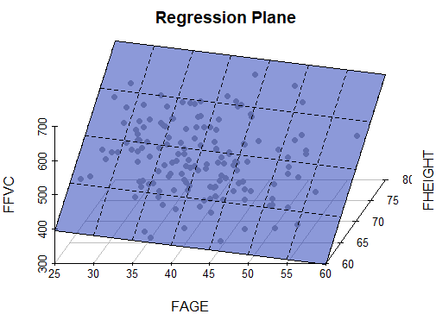

**3.2**

**From the depression data set described in Table 3.4, predict the reported**

**level of depression as given by CESD, using INCOME, SEX, and AGE as**

**independent variables. Analyze the residuals and decide whether or not it is**

**reasonable to assume that they follow a normal distribution.**

Call:

lm(formula = CESD ~ INCOME + SEX + AGE)

Residuals:

Min 1Q Median 3Q Max

-0.8762 -0.5646 -0.3863 0.4040 2.6676

Coefficients:

Estimate Std. Error t value Pr(>|t|)

(Intercept) 0.816071 0.226172 3.608 0.000363 ***

INCOME -0.006795 0.003155 -2.154 0.032086 *

SEX 0.117834 0.097597 1.207 0.228283

AGE -0.006741 0.002626 -2.567 0.010766 *

---

Signif. codes: 0 ‘***’ 0.001 ‘**’ 0.01 ‘*’ 0.05 ‘.’ 0.1 ‘ ’ 1

Residual standard error: 0.7979 on 290 degrees of freedom

Multiple R-squared: 0.03906, Adjusted R-squared: 0.02912

F-statistic: 3.929 on 3 and 290 DF, p-value: 0.008995

**Regression equation:**

**CESD= -0.006 *INCOME +0.117*SEX -0.0067*AGE +0.816**

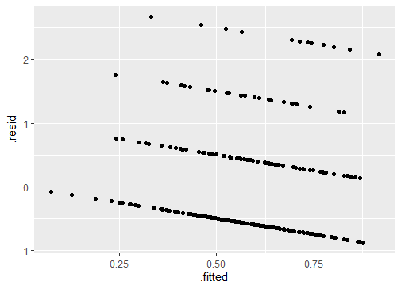

**Residual plot shows linearly decreasing pattern for residual. Therefore, we cannot assume that they follow normal distribution.**